ENG 3U POETRY ANALYSIS QUESTIONS AND WORK
Wilson

Learning Goal: I will demonstrate an understanding of different forms and styles of poetry and poetic devices by analysing various poems.

Success Criteria:
[] I will read three poems assigned to me from Viewpoints 11
[] I will analyze poems looking for literal and metaphorical meaning, poetic devices, rhythm (metre), rhyme scheme, theme, and any other notable elements in the poem
[] I will use direct lines from the poem to support some of my responses (referencing in MLA style:
When short (fewer than three lines of verse) quotations from poetry, mark breaks in short quotations of verse with a slash, ( / ), at the end of each line of verse (a space should precede and follow the slash).
Cullen concludes, "Of all the things that happened there / That's all I remember" (11-12) Line numbers from poem
[] I will support my analysis with explanations and support as required in my answer

Steps:
Read your poems. Answer the following questions separately for each poem. Note the “Notes” that are included in the textbook for each poem at the end of your section.

- In a short paragraph, summarize what the poem is about. Provide evidence/support.

- In a few sentences, explain the possible meaning of the poem. Provide evidence/support.

- Identify two poetic devices from the poem. Include an MLA reference (with line numbers) in your answer, and explain how the device is used.

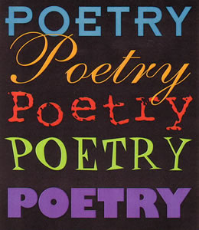
- Write a short paragraph on the poem. What are your thoughts, reactions, feelings, and recommendations? Be specific and explain your reasons – with examples and support as required.

Marks:
THINKING /10
KNOWLEDGE /10

TOTAL /20

