Assignment
For this assignment, you will write a tabloid-style news article about an issue within The Merchant of Venice. Your issue might be a scandalous romance, the loan, a conflict between characters – or anything that follows the subject of the play.

What’s a Tabloid?
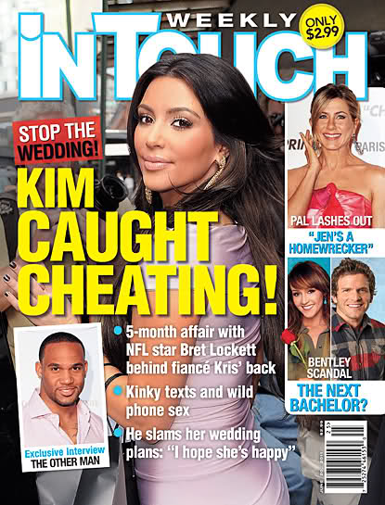
Tabloid newspapers use sensationalist writing. This means the writer might exaggerate, embellish, or even make up facts in an attempt to sell the story. Celebrity gossip magazines are an example of tabloid writing. You’ve seen this in those magazines near the cashier of stores.

Sample Ideas
-Antonio and Bassanio in a Secret Gay Relationship
-Jew & Christian Tear Apart Traditions
-Portia Pregnant… With Shylock’s Baby!
-Jessica and Portia Spied Together In Romantic Shocker
-Shylock Secretly Owes Millions

Success Criteria
[ ] I will show knowledge of major elements (character, plot, conflict, theme) of the play in my writing
[ ] I will write in the style of a tabloid paper (See online examples)
[ ] I will insert quotes from characters who are involved
[ ] I will include a catchy headline
[ ] My news report will inform on the 5Ws+H (Who, What, Where, When, Why, How)
[ ] My report will be divided into clear, effective paragraphs
[ ] I will edit for spelling, grammar, and clear ideas
[ ] I will work to make my article appear authentic (i.e. ads on page, old-timey look, etc.)

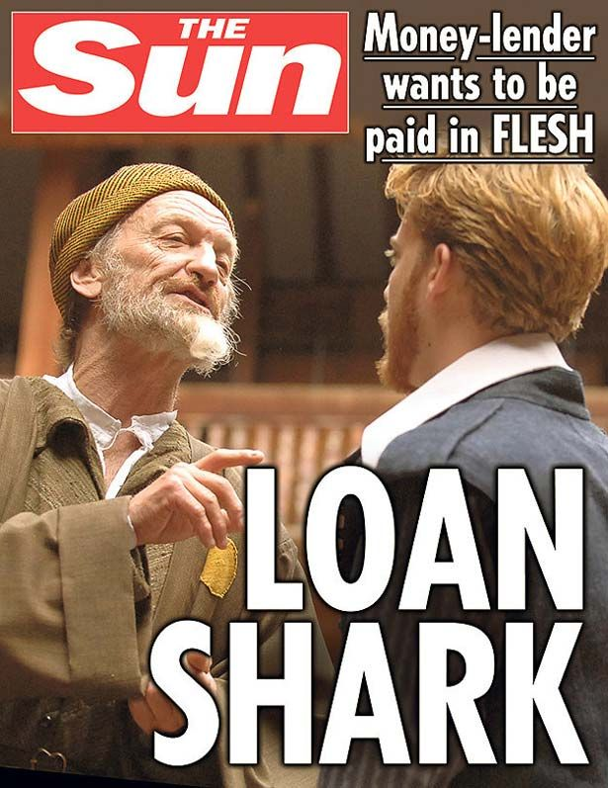
Marks
Knowledge of Play Content 1 2 3 4 5
Style and Content of Article 1 2 3 4 5
Creativity Within Article 1 2 3 4 5
Spelling/Grammar/Application 1 2 3 4 5

