NBV 3E ABORIGINAL IDENTITY: CLAN SYSTEMS
Wilson

"What is your doodem?" ("Aaniin odoodemaayan?")

CLAN: -A group or association to a family group that includes certain roles and responsibilities. Clans include colours, symbols, and territories.

-Clans are also called Totems (from the Anishinaabe word doodem).

-Clan Names are usually based on animals. They were traditionally important for things like jobs, marriages, and relationships with other tribes.

OJIBWAY PEOPLE: Seven Clans HAUDENOSAUNEE PEOPLE (Six Nations): Nine Clans
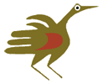
Moshkas miinawa Maang
1 & 2 - The crane and loon clans are the leaders and the chiefs. They both work together for the good of all the people in the nation.
Giigonh
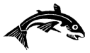3 - The fish clan settles arguments between the crane and loon clans. They are the wise people. They solve the problems within the nation. The turtle is the leader of the fish clan. In this clan we have different types of fish such as migrating, territorial, bottom feeders, top eaters, late spanners, early spanners.
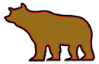
Makwa
4 - The bear clans are the ones who patrol the woods around the community to watch for danger. They also know how to use the plants for medicine.
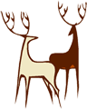

Wawashkesh
5 - The deer clan is the gentle people in the nation. They are the poets and the peace makers. Everything they do is kind and gentle.
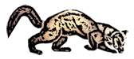Waabizhishi
6 - The martin clans are the warriors who fight to protect the nation. They are respected for their bravery and skills.
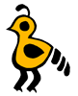
Binenhshiinh
7 - The bird clans are the spiritual people. They are known to predict the future. There are different types of birds in this clan such as waterfowl, land fowl, treedwellers, insect eaters and seed eaters.

