***NBV 3E CHILDREN’S STORY WRITING ASSIGNMENT***

*Wilson*

Aboriginal Children’s Story Assignment

Over the next few classes, you will be putting together a children’s book that follows the topic of Aboriginal Creation Stories. Put your ideas together in a book suitable for a young audience, (between six to ten years old). The focus of the book is **Creation Stories** (e.g. how skunk got her stripes; why the poplar tree shivers; how bear lost his tail, etc.)

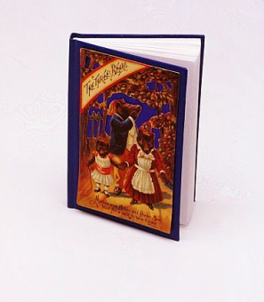The best thing about children’s books are that they have a small amount of words on each page and instead use pictures and art to help tell the story.

Your children’s story will have the following components:

🡪Be at least ten pages long using folded sheets of white paper

🡪Have a suitable cover

🡪Include appropriate and creative pictures and illustrations

🡪Focus on an issue of Aboriginal Identity

🡪Be appropriate for young audiences

You will have several days of class time to work on this assignment but if that work does not get finished you will be responsible for finishing this assignment on your own time.

THINGS I WILL PROVIDE: THINGS YOU NEED TO PROVIDE:

Bristol Board & Construction Paper Pencil Crayons/Markers

Scissors The Actual Story

Glue Effort in class

White Paper

You will need to do the following:

🡪Come up with your story in rough copy on lined paper. You will use this rough copy to edit and revise your work following the steps of the Writing Process

🡪Fold and staple pages together to make a book. A folded sheet of white paper becomes four pages when put into a book. You will use these pages to add your words and pictures.

🡪Put the words and pictures on the page. Refer to children’s books that you remember for ideas

🡪Create a colourful and creative cover

🡪Use your time effectively

MARKING:

Use of Class Time: /10 TOTAL: /60

Following Steps: /15

Identity Theme /15

Final Product: /10

Written Work: /10