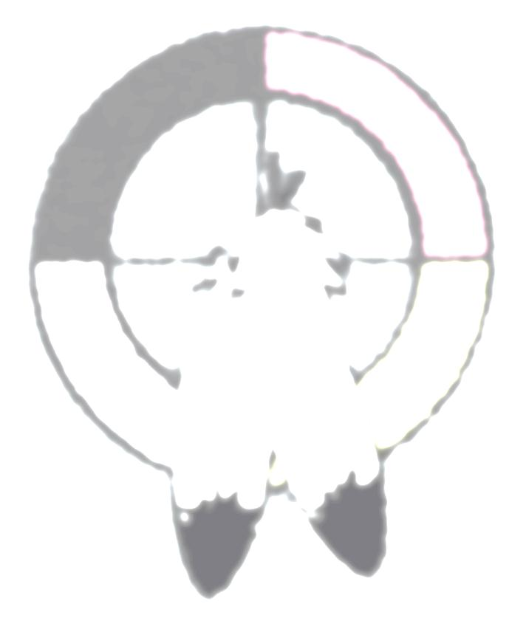
LEARNING GOAL: I will demonstrate an understanding of Aboriginal beliefs and values by showing an understanding of the Seven Grandfather Teachings.

WHAT TO DO…
For this assignment you will choose one of the Seven Teachings of the Grandfathers and do some research on it. Your research must include:

The meaning of the teaching – What is it all about?
The relationship of the teaching – how does it connect to your idea of identity?
The connection between this teaching and the other Seven Teachings

WHAT TO CREATE…
- An illustration or picture representing your teaching. It could be something you create or something you find in magazines, online, etc.
- A minimum of two paragraphs explaining your illustration or picture AND the answers to the three points above.
SUCCESS CRITERIA…
[ ] I will choose one of the Seven Grandfather Teachings to research
[ ] I will think about, research, and organize information about the meaning, relationship and connections between the teaching I choose and the other teachings
[ ] I will create a visual representation that is thoughtful, creative, meaningful, and of a high quality and effort
[ ] I will write at least two organized paragraphs that explain my illustrations and provide information about the meaning, relationship, and connection of my teaching
[ ] I will use my own ideas
[ ] My final copy will be written or typed neatly and show high effort and high quality

MARKS…
KNOWLEDGE – Knowledge of the teaching, Information provided, /20
Answers to questions and instructions

THINKING - Detail and connections in answers. Thoughtfulness of information /10

APPLICATION - Information is clear and complete. Effort is shown. /20

TOTAL /50

