Learning Goal: Students will understand the impact and importance of Canada’s Residential School System.

ASSIGNMENT:
Students will create a project that teaches others of the importance and impact of Residential Schools. Students can choose to create their own item that will teach others about Canada’s Residential Schools system, how it affected First Nation, Métis, and Inuit people and why it’s important to know about it.

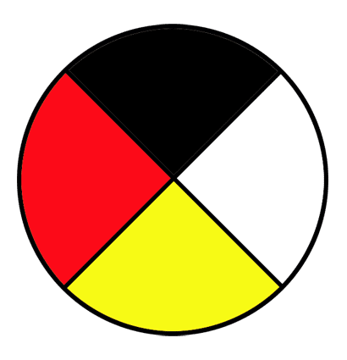
IDEAS:
-Mural/Poster on large paper -Brochure -Comic Strip
-Short Writing/Poetry/Story -Painting -PowerPoint

Once you choose your idea, you will need to decide how you will include the following pieces that are mandatory:
- Images (For example, of Residential schools, survivors, Aboriginal families)
- Quotes (For example, Government Apology, Government officials, survivors, etc.)
- Important Words (For example, assimilation, racism, suffering, abuse, history, Canada)
You can find ideas and information in resource packages that have been created for this assignment.
Your project must include the following information in some way:
Shows why and how Residential Schools affected FNMI people
Shows why people should continue to recognize and know about Residential Schools
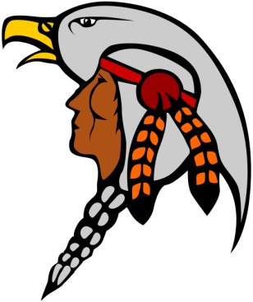
SUCCESS CRITERIA:
[ ] I have chosen an idea that I find interesting
[ ] I have included images, quotes, and important words related to Residential Schools
[ ] I have shown why knowing about Residential Schools is important
[ ] I have shown how Residential Schools have affected many people
[ ] My project is interesting, original, and creative
[ ] I have put honest and fair effort into my work
[ ] I have effectively used class time to complete the project

MARKING:
Knowledge of Residential School Information /20
Application of Ideas – Putting it All Together /20
Communication of Information /10

TOTAL MARKS /50

