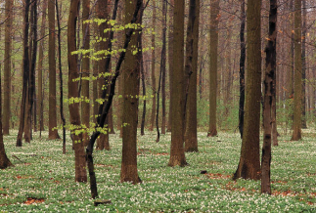***NBV 3E SOVEREIGNTY: ABORIGINAL LAND CLAIMS***

*Wilson*

Land for First Nations people has been a part of government planning since the 1700s. Since that time, land claim issues have been in the media as Aboriginals protest for ownership of their traditional lands.

Either with a partner or alone, choose one of the following land claim issues and complete the following assignment. Use the Internet to find information.

**CHOICES:**

OKA Crisis Ipperwash Crisis Grassy Narrows BC Nisgaa People

Haidi – Queen Charlotte Islands Gustafsen Lake Standoff Burnt Church Crisis

New Brunswick Natural Gas Protest Grand River Land Dispute Ring of Fire Blockades

**WHAT TO DO…**

Use the Internet (Google and Wikipedia are pretty awesome) to find out information. Then, answer the following questions.

1. **Write a summary of the crisis. Be sure to include WHO was involved, WHERE the crisis occurred, WHEN it happened and WHAT it was about. Your summary must:**

**-Be written in clear sections for each part (full sentences)**

**-Include detailed information**

1. **Include a map of the PROVINCE or TERRITORY involved. On your map, indicate where the crisis occurred. Make sure your map**

**-Has a title**

**-Is labeled**

1. **Answer the following questions:**
2. What aboriginal traditions exist concerning the use of and interaction with the land?
3. In what ways are aboriginal peoples trying to recover their traditional connections with the land?
4. What barriers are stopping aboriginal efforts to reclaim their traditional connections with the land?
5. What impact has industry (i.e. factories, fishing, mining, forestry, etc.) had on the land claimed by the Aboriginal Peoples?
6. Why do aboriginal land claims tend to be disputed over?

**MARKS…**

**Application /10**

**Communication /10**