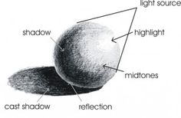
HOW TO SHADE CORRECTLY
- Blend smoothly and gradually. The changes in tone
should be slow
- Shading should following the shape of an object
- Objects with multiple parts have each part shaded
separately. For example, a can would have the side
and top shaded in different directions

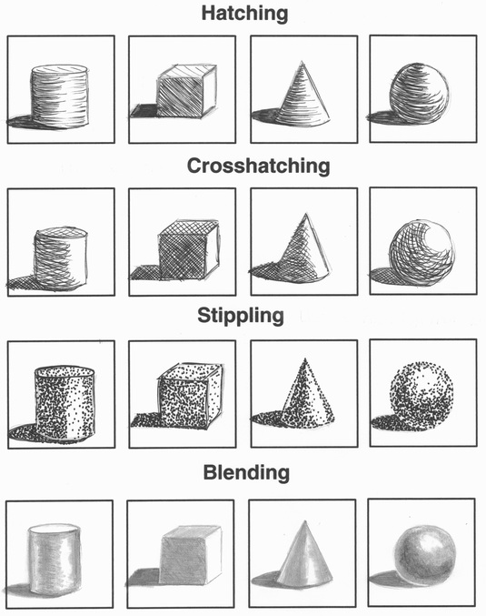
TYPES OF SHADING TECHNIQUES

SHADING PRACTICE
Shade each shape using hatching, crosshatching, and then blending.
HATCHING | CROSSHATCHING | BLENDING

Use one of the shading techniques to add value to the following object.

SHADING ASSIGNMENT
Learning Goal: I will demonstrate an understanding of value and shading techniques by choosing an object, drawing its outline, and shading it.
Success Criteria:
- I will think carefully and plan thoughtfully about what object to shade. After choosing my object, I will create an outline of it on 8.5” x 11” paper using light pencil lines
- I will demonstrate an understanding of value by using one of the shading techniques to fully shade in my object
- I will demonstrate an understanding of value by following the rules of being smooth and gradual with my shading and following the curves of the object
- I will demonstrate an understanding of value by using just a pencil and eraser and no other tools, (e.g. paper to smudge)
- I will apply my skills to create a drawing that reflects my true abilities
 | LEVEL 1 | LEVEL 2 | LEVEL 3 | LEVEL 4
 | 50-59% | 60-69% | 70-79% | 80-100%
Student demonstrates an understanding of value and shading techniques(Knowledge) | Student demonstrates a limited understanding of value and shading | Student demonstrates some understanding of value and shading | Student demonstrates a considerable understanding of value and shading | Student demonstrates an exceptional understanding of value and shading
The drawing involves planning and thinking about how it will be put together  (Thinking) | A limited amount of planning and thinking occurred for this assignment | Some amount of planning and thinking occurred for this assignment | A considerable amount of planning and thinking occurred for this assignment | A thorough amount of planning and thinking occurred for this assignment
Drawing reflects information from lessons and student abilities/effort  (Application) | Drawing reflects limited information from lessons and student abilities/effort | Drawing reflects some information from lessons and student abilities/effort | Drawing reflects considerable information from lessons and student abilities/effort | Drawing reflects thorough information from lessons and student abilities/effort
Tools and materials were used appropriately  (Knowledge) | Tools and materials were used appropriately to a limited extent | Tools and materials were used appropriately some extent | Tools and materials were used appropriately to a considerable extent | Tools and materials were used appropriately to a thorough extent
MARKS 1 2 3 4 5 6 6.5 7 7.5 8 9 10
Examples and Ideas:
