You will design a postcard celebrating northwestern Ontario using watercolour paints and watercolour paper. Here are the steps to follow:

- PLAN: Use regular paper to plan your design. You might think of the
following ideas to celebrate northwestern Ontario:
Wildlife (Birds and Animals)
A forest scene
Fishing/Hunting
A small town scene (like a main street)
A cottage/cabin
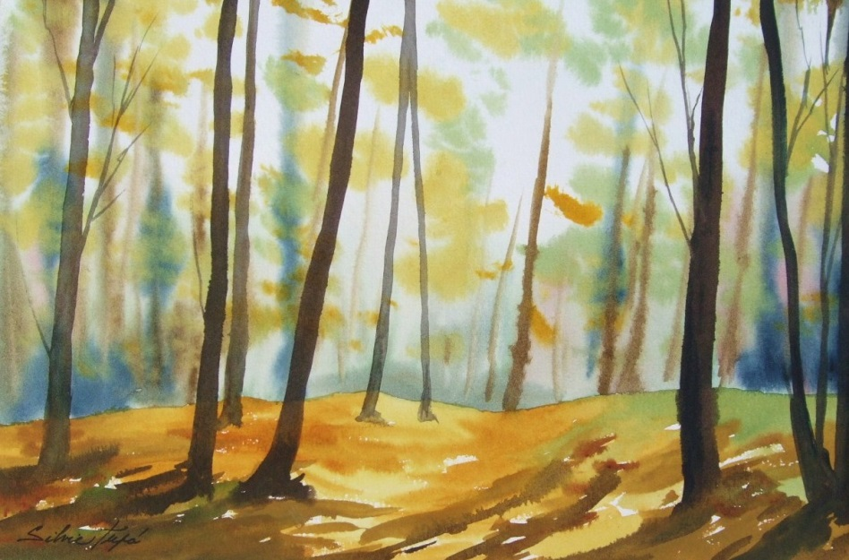
Sketch out your plan on white paper. Use shading techniques

- PAINT: Watercolours involve a few steps to make it work:
- Use VERY LIGHT PENCIL LINES to make outlines (like a colouring book)
- Start with your BACKGROUND and end with the FOREGROUND
- Play with COLOUR and VALUE to make it interesting
- Work creatively with the SPACE you are using (use as much as you can)

- HAND IN: Hand in the rubric with the painting

Name: _____________
WATERCOLOUR PAINTING PROJECT
RUBRIC
 | Level 0 | Level 1 | Level 2 | Level 3 | Level 4
Knowledge  I will demonstrate knowledge of watercolour painting techniques | I have not completed this part of the assignment | I have demonstrated a limited knowledge of watercolour techniques | I have demonstrated some knowledge of watercolour techniques | I have demonstrated considerable knowledge of watercolour techniques | I have demonstrated a thorough knowledge of watercolour techniques
Thinking  I will plan out my work to celebrate northwestern Ontario and use colour, value, and space appropriately | I have not completed this part of the assignment | I have not done very much planning for my watercolour painting | I have done some planning for my watercolour painting | I have done quite a bit of planning for my watercolour painting | I have done a great job planning my watercolour painting
Application  I will make appropriate use of materials and put the appropriate effort toward my assignment | I have not completed this part of the assignment | I made poor use of materials, time and effort | I made some good use of materials, time, and effort | I have made mostly good use of materials, time and effort | I made an awesome use of materials, time and effort

MARK: ___/20
FEEDBACK FROM TEACHER:

