ENG 2P LORD OF THE FLIES: CHAPTERS 11 & 12 QUESTIONS
Wilson

Answer the following questions in full sentences. Provide evidence from the novel to support your answers. You must choose at least two responses and include a quote from the novel, including page number. Example: Jack clearly shows his evil as he tortures the boys: “He lifted his spear and jabbed SamnEric in the face. He laughed at them as they screamed (114).
- Why is the boys’ attempt to get back Piggy’s specs and hold a meeting with the other boys bound to fail?

- Explain, with support from the novel, how the theme of “childhood innocence” is lost and how the theme of “human cruelty” is highlighted.

- If Lord of the Flies is a response to society after World War II, what do you think the death of Piggy by the rock represents?

- Explain the symbolic importance of the conch being destroyed into millions of tiny fragments. What did the conch represent?

- Explain why Ralph hits the pig head.

- What do Samneric mean when they tell Ralph that Jack has “sharpened a stick at both ends”? What do you think the reason for Jack’s hatred is?

- What foolish method do the boys use to ensure that they find Ralph? What does this decision suggest about the power of hatred and violence versus the power of reason?
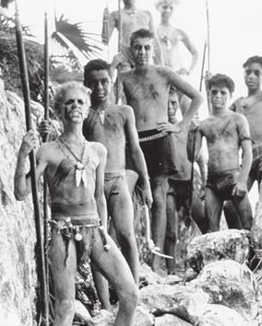
- What is ironic about how the boys are saved? What is ironic about the fact that the boys, who have become savages, are British, and why do you think Golding chose to write about a group of British boys? Consider what the naval officer says: “I should have thought that a pack of British boys would have been able to put up a better show than that.”

