ENG 2P LORD OF THE FLIES: CHAPTERS 8-9
Wilson

- Create a graphic organizer that outlines the following parts of the novel up to the end of these chapters. Use point form and be as complete as possible.
NOVEL ELEMENT | COMMENTS/NOTES
PLOT
CONFLICT
THEME

- Explain, using examples from the novel, how the boys have become uncivilized during their time on the island.

- In Chapter 8, how does Piggy show some “intellectual daring”? Why is this important to the boys?

- What do Jack and the other big kids decide to do about the beast? What does this show readers about human nature? (Connect this to the last question).

- What happens to Simon after the hunters leave his clearing? What is the “lord of the flies”? What does it represent? How does it talk to Simon—what does its speech really mean?

- Why does Jack command the boys to dance and chant, and why is this an effective leadership tactic? What psychological effect does dancing and chanting have on the boys? Think back to the effect that putting on makeup had on them in Chapter 4.

- What is the “beast” that the boys kill? How is this event ironic and especially tragic (not only for the “beast,” but for everyone on the island)? How is it symbolically significant?

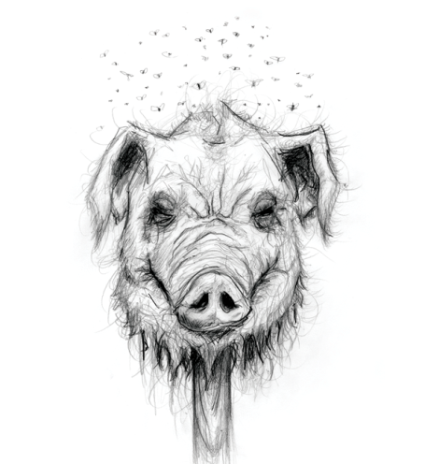
- Why do you think Golding decided to have the “figure” fly over the boys on the beach and into the sea? Why do you think he had Simon’s body get washed away, and what does this represent in a psychological sense?

