ENG 2P NEWS ARTICLE RESPONSE QUESTIONS
Wilson

For each of the following questions make sure you answer the question, provide support, and make an explanation where necessary.

Read the CBC.ca news article “CAMH Calls For Legalization of Marijuana” (October 9, 2014)
http://www.cbc.ca/news/canada/toronto/camh-calls-for-legalization-of-marijuana-1.2793460 and answer the following questions:

- What is the CAMH? Why would their opinion be valuable for this topic?

- According to the article, why is Canada’s current system of cannabis control failing? Provide evidence from the article.

- Summarize some of the controls that the CAMH is proposing if marijuana were to be legalized.

- Explain some advantages of the legalization of marijuana, based on information in the article.

- What are some potential negative points about the legalization of marijuana? Explain your answers.

- Based on the “10 Basic Principles” guide created by CAMH, what principle is the most important? Which do you think is least important? Support your answer with your own ideas.

- If the government did legalize marijuana, should they also include youth aged sixteen and older? Support your answer with information from the article and your own opinions. You should write at least one paragraph on this topic.

CAMH calls for legalization of marijuana

Current system 'failing to prevent or reduce the harms' of pot use, researcher says
CBC News Posted: Oct 09, 2014 6:23 AM ET Last Updated: Oct 09, 2014 10:38 AM ET
Physicians at Canada's largest addictions and mental-health research centre, CAMH in Toronto, are calling for the legalization of marijuana with controls to reduce harm to users. (Canadian Press)

Marijuana should be legalized with strict controls to curb its use and social harms, the Toronto-based Centre for Addiction and Mental Health says.

Canada’s current system of cannabis control fails to prevent or reduce harms associated with its use, Dr. Jurgen Rehm, director of social and epidemiological research at CAMH, said Thursday as the hospital released a new policy document on the drug.
"Cannabis sales should be regulated," Rehm said in an interview with CBC Radio’s Metro Morning.
"There should be a government monopoly on sales. There should be a minimum age for purchase and consumption. There should be controls on availability. There should be … a ban on marketing, advertising and promotion and plain packaging."
Rehm estimated that about 40 per cent of Canadians have used pot at least once in their lifetimes, and 10 per cent have done so in the past year. But its use is associated with harms to health, including:
- Respiratory diseases such as lung cancer.
- Problems with healthy development from high levels of use by youth.
- Risk of death or injury from motor vehicle collisions.
- Dependence and mental-health problems.
Given the risk of harm, CAMH believes any reforms on marijuana control need to include a strong focus on prevention and harm reduction interventions.
Anyone who buys pot in criminal markets doesn't know about its potency or quality. Meanwhile, enforcement of cannabis laws costs Canadians $1.2 billion a year, the centre said.
While decriminalization has some advantages over prohibition, it doesn’t address health harms of cannabis use as strict regulations would, Rehm said, adding the strict regulations proposed set the model apart from other legalization approaches, such as in the U.S.
In May, the Canadian Public Health Association also issued a policy statement saying "Canada needs a public health approach to managing illegal psychoactive substances that de-emphasizes criminalization and stigma in favour of evidence-based strategies to reduce harm."
Ian Culbert, the group’s executive director, said a different approach is needed than the current "war on drugs."
"Canadian society isn't overnight going to embrace this idea of legalization and regulation, so it's a conversation that we have to have," he said.
CAMH’s recommendations also included:
- A framework to address and prevent cannabis-impaired driving.
- Better access to treatment.
- Investment in education and prevention.
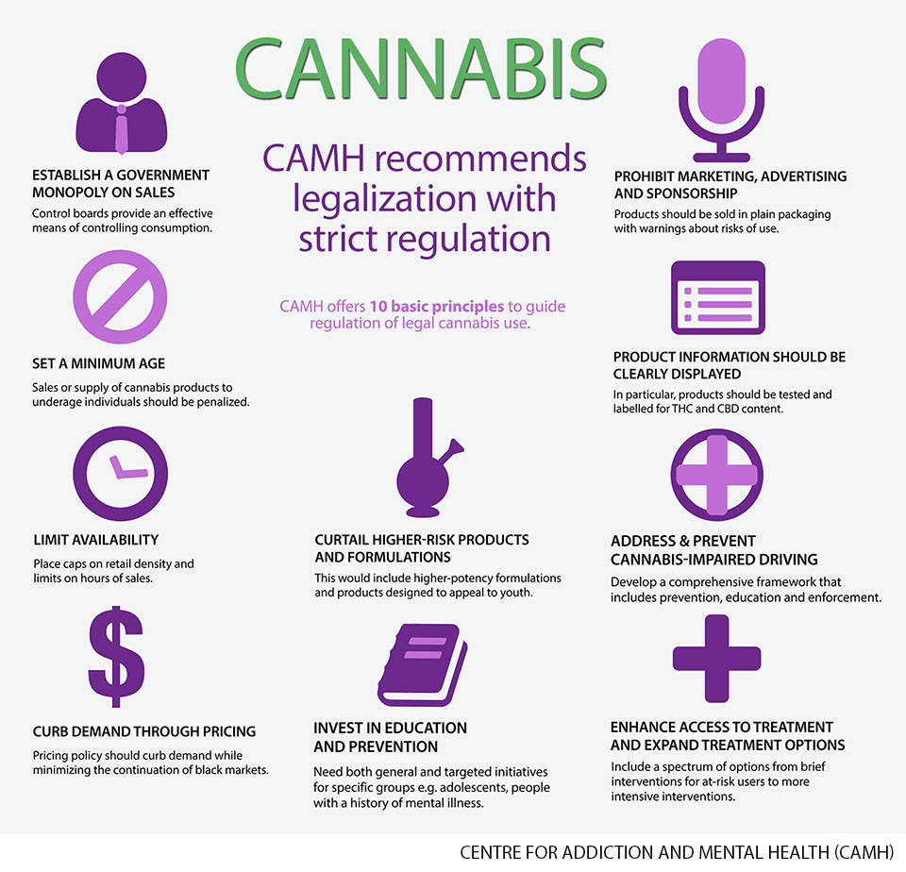
Experts from CAMH started to develop the new policy framework last year.

