Write a news report based on the following headline and photograph. You will need to make up the facts and information to answer some or all of the following questions: Who? What? Where? When? Why? How?

Length: Approximately 20 lines of “regular-sized” writing

Fire Destroys Local School
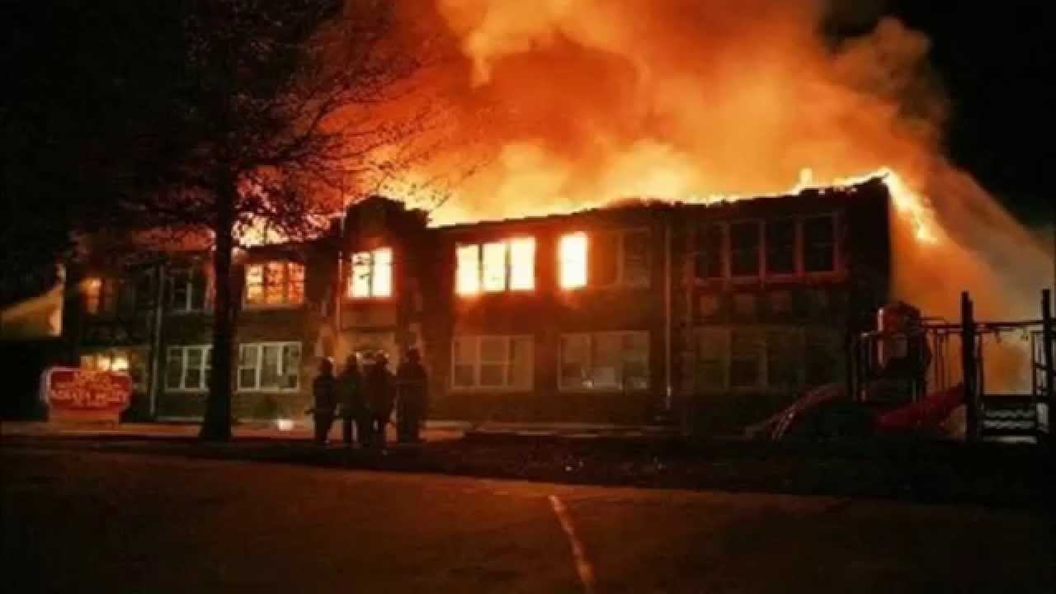

MARKS:
MARK | DESCRIPTION
1 | Supporting Details Included
1 | Organization
1 | Spelling/Grammar
1 | Quotes (At least two)
1 | Transitions (Connections Between Paragraphs)
1 | Detail
**No marks will be given if the news report is off-topic or not written as a news report.

