GESTURE DRAWING
-Quick sketch that captures human figure
-More than just stick figures
-Focuses on joints and positioning of body
-Includes quick lines and minimal detail
-Lines follow shapes of C-S-I
-Usually created in around 1 minute.
-Helps develop skill of capturing poses

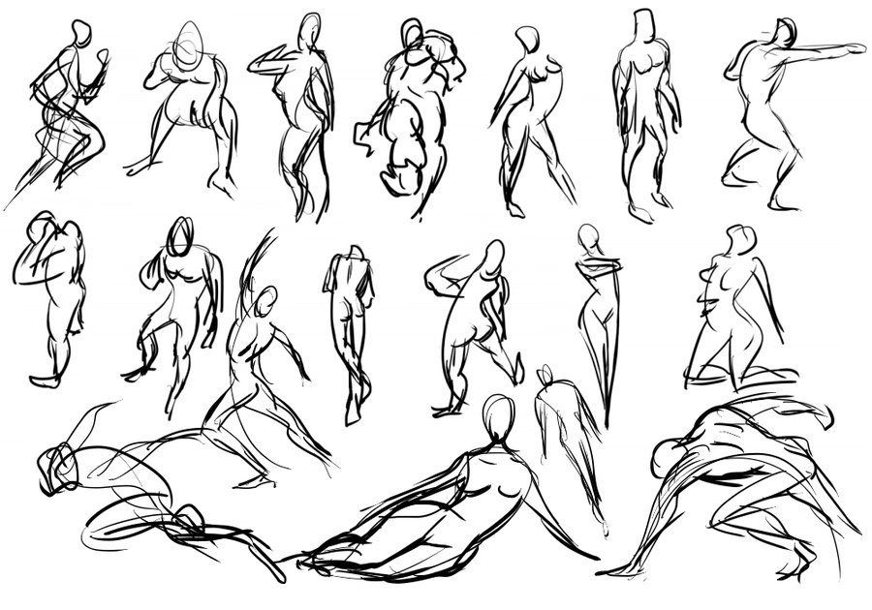
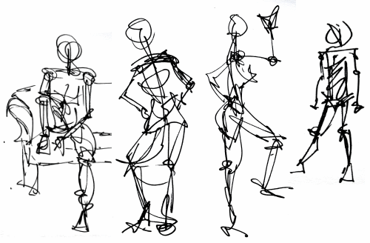

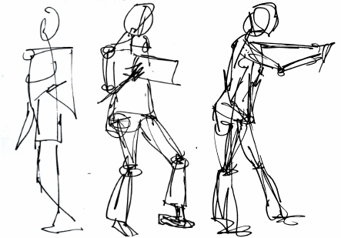

CONTOUR DRAWING
-Focuses on the outlines of an object/objects
-Focuses on the shape/form of objects rather than detail
-Can be continuous (artist doesn’t lift pencil)
-Builds technique of transferring what is seen to what is drawn

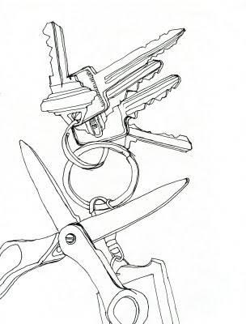
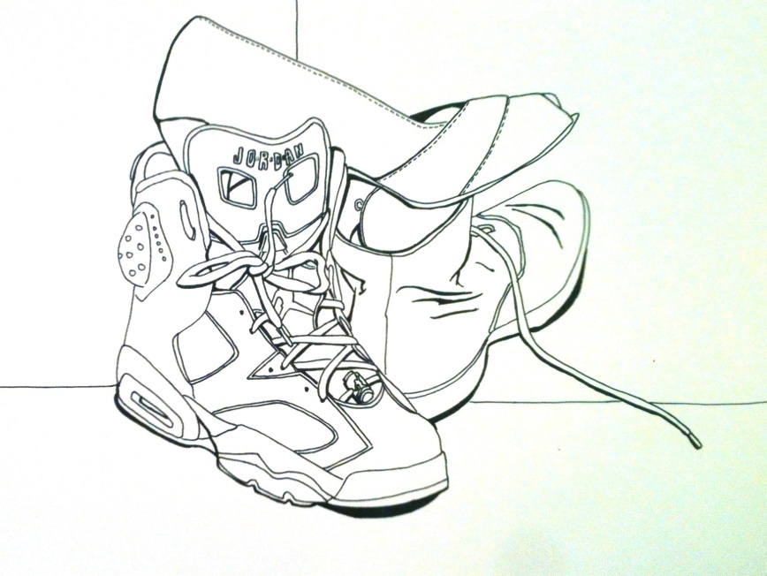
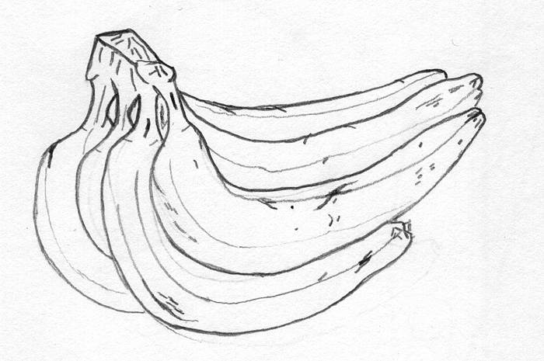

BLIND CONTOUR DRAWING
-Builds technique of muscle control
-Builds technique of relationship of object size
-Artist does not look at page
-Focuses on the outlines of an object/objects
-Focuses on the shape/form of objects rather than detail
-Can be continuous (artist doesn’t lift pencil)
-Builds technique of transferring what is seen to what is drawn
