

**Introduction**

Your final portfolio project involves the creation of a series of studio pieces reflecting your choice of visual art types, (including sculpture, photography, painting, printmaking, and drawing) that are united by a main theme or idea.

This portfolio will represent your interest, abilities, and skills and will hopefully be something you put time and effort into so it reflects your true abilities.

**Studio Creations**

* You will create a **MINIMUM** of **FOUR** (AVI3O) **SIX** (AVI3M) studio pieces that reflect on a main theme or idea.
* You must choose at least TWO different types of visual art for your project
* Class time from now to the end of the semester is designated for this culminating project

**Studio Work Criteria**

1. **Artistic Statement**

🡪You will write a paragraph describing what your pieces are trying to achieve. What theme or idea are you representing? What are you trying to accomplish through your art?

1. **Creative Process**

🡪Provide evidence of planning, designing, changing, and reflecting on your work for at least **ONE PIECE** if you are in **AVI3O** and **TWO PIECES** if you are in **AVI3M**. This might include sketches, rough copies, etc.

1. **Reflection/Statement for Each Piece**

🡪You will write a paragraph/blurb for each piece that includes a title, media, and measurements. You will write a commentary for each piece with a short reflection on what you’ve created. Ensure that your pieces are edited for spelling and grammar.

🡪You will complete a Critical Analysis (Description, Analysis, Interpretation, Judgement) sheet for **TWO PIECES** of your studio work.

1. **Presentation**

🡪Your works will be presented in a gallery style. You will have space provided in the classroom so that other students/staff may come in and appreciate your work. Think of a trade show-style display.

🡪Consider how you will display your pieces and your written work

**Evaluation Questions**

You will be asked the following questions about your Culminating Task. Prepare your answers and be ready to discuss them. Note that this is worth 25% of your final project mark.

1. Discuss the organization of your portfolio (thematic, chronological, grouped by medium, etc.). How did you decide on this format?
2. Explain how your portfolio shows evidence of the creative process.
3. Discuss how a piece of your work shows an influence of art works and artists from the past.
4. Determine what you consider to be the main strength of your portfolio.
5. Assess an area(s) where you think you could improve.
6. Explain why the works you chose for your portfolio are the most appropriate for inclusion.
7. Name three skills that you have acquired through the visual arts and explain how they could be applied to other contexts.
8. Justify how your portfolio shows evidence of creative thought.

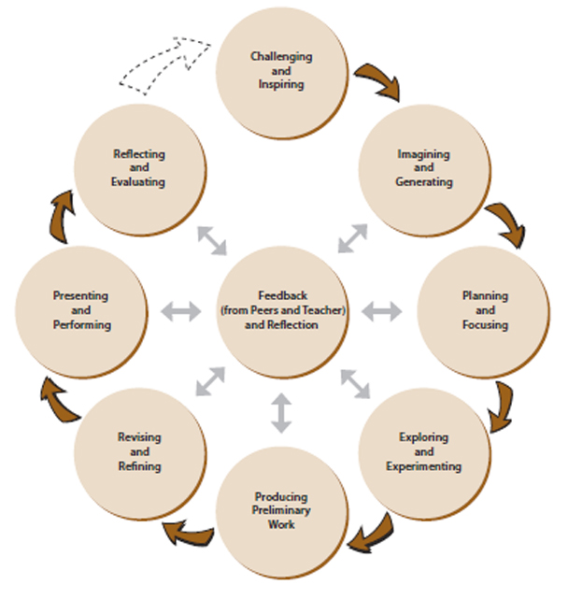

***MARKING SCHEME/RUBRIC***

**CONTENT /40**

Overall quality of included works 0 2 4 6 8 10

Variety of Work 0 2 4 6 8 10

Number of pieces 0 2 4 6 8 10

Evidence of Creative Process 0 2 4 6 8 10

**DOCUMENTATION/WRITING /20**

Artist’s Statement 0 1 2 3 4 5

Details/Info in Studio Piece Paragraphs 0 1 2 3 4 5

Edited for Spelling/Grammar 0 1 2 3 4 5

Neat, Organized, Professional Presentation 0 1 2 3 4 5

**LAYOUT AND PRESENTATION /15**

Professionalism 0 1 2 3 4 5

(All pieces laid out and presented in an  
 organized manner)

Originality/Creativity 0 1 2 3 4 5

Overall Effort 0 1 2 3 4 5

**PORTFOLIO EVALUATION QUESTIONS /25**

Discuss organization of portfolio 0 1 2 3 4 5

Discuss evidence of creative process 0 1 2 3 4 5

Discuss influence of other artists/works 0 1 2 3 4 5

Discuss strengths of portfolio/assignment 0 1 2 3 4 5

Discuss areas to improve upon in future 0 1 2 3 4 5

***TOTAL MARKS: /100***

**COMMENTS/NEXT STEPS:**