Answer the following questions using information from the Aboriginal Peoples of Canada textbook and the film “We Were Children”.
- Provide a definition for the following words:
- Genocide b. Assimilation c. Colonialism
- Marginalization e. Economy

- Explain how residential schools took away the identity of First Nations children. See the quote on the top of p. 68 and the graphic and point-form information on p. 69-70. Explain how this changed First Nations people.

- If a child lost the ability to speak their traditional language, how could this change the relationship with their family? What affects would this have on people?

- Take a look at the painting by Daphne Odjig on p. 71. Answer the question: What does this painting say to you about the effects of colonialism on the Aboriginal peoples of Canada? Here’s a black-and-white copy of the painting:
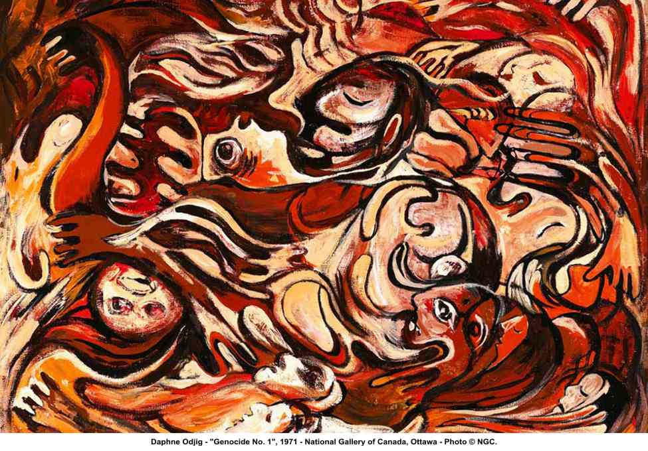

- After seeing the film “We Were Children”, do you think that most Canadians really know about what went on in Residential Schools? Why or why not?

- Do you see any connection to the issues that First Nations people are facing now (suicide, alcoholism, drugs, etc.) to the history of 100 years of time that children were forced to spend in Residential Schools?

- What was the most surprising thing that stood out to you about the film, “We Were Children”?

