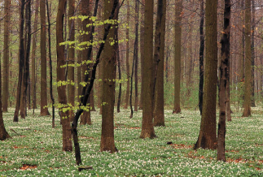***NAC 2O LAND USE: ABORIGINAL LAND CLAIMS***

*Wilson*

Land for First Nations people has been a part of government planning since the 1700s. Since that time, land claim issues have been in the media as Aboriginals protest for ownership of their traditional lands.

Either with a partner or alone, choose one of the following land claim issues and complete the following assignment. Use the Internet to find information.

**CHOICES:**

OKA Crisis Ipperwash Crisis Grassy Narrows Greenstone Gold Mines

Haidi – Queen Charlotte Islands Gustafsen Lake Standoff Ginoogaming Hydro Settlement

New Brunswick Natural Gas Protest Attawapiskat – Diamond Mine Ring of Fire Blockades

**WHAT TO DO…**

Use the Internet (Google and Wikipedia are pretty awesome) to find out information. Then, answer the following questions.

1. **Write a summary of the crisis. Be sure to include WHO was involved, WHERE the crisis occurred, WHEN it happened and WHAT it was about. Your summary must:**

**-Be written in clear sections for each part (full sentences)**

**-Include detailed information**

1. **Include a map of the PROVINCE or TERRITORY involved. On your map, indicate where the crisis occurred. Make sure your map**

**-Has a title**

**-Is labeled**

1. **Answer the following questions:**
2. What aboriginal traditions/land uses were threatened by this issue?
3. Is this issue settled? What settlements were made to the people?
4. What impact has industry (i.e. factories, fishing, mining, forestry, etc.) had on the land claimed by the Aboriginal Peoples? How has it changed ways of life?
5. Create a T-Chart list of the pros and cons of this land use development/issue/activity

**MARKS…**

**Application /10**

**Communication /10**