For this assignment, you will choose a major historical event in First Nation, Métis, and Inuit relationships with non-Aboriginal people. You will create a poster with information about the event so that we can create a timeline for the classroom. You must choose an event different from everyone else in class.

LEARNING GOAL: Demonstrate an understanding of the changing way of life of FNMI people as they built relationships with non-Aboriginal people.

SUCCESS CRITERIA:
- I will research a significant historical event about First Nation, Métis, and Inuit relationships with non-Aboriginal people in Canada
- I will summarize my research to create a poster with the following information:
  - WHAT: What the event was about (an explanation of what happened)
  - WHY: An explanation of why this event is important for FNMI people
  - WHO: Who were the major people involved
- I will arrange my information so it fits on one regular piece of paper and is eye-catching, (e.g. contains clear a clear year/date/title, clear fonts, at least one image, and the appropriate information
- I will edit for spelling and grammar

WHERE TO FIND TOPICS: Use Wikipedia! There’s a great page on
major events: https://en.wikipedia.org/wiki/Timeline_of_First_Nations_history
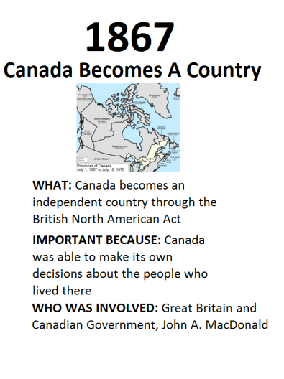
- You are required to tell me your choice!

MARKING:
KNOWLEDGE:
Demonstrates knowledge of relationships, detail of event
1 2 3 4 5

THINKING:
Demonstrates why and how event is important to FNMI people
1 2 3 4 5

COMMUNICATION:
Demonstrates clear ideas and polished spelling/grammar
1 2 3 4 5

APPLICATION:
Demonstrates how this information connects with other events in history
1 2 3 4 5

