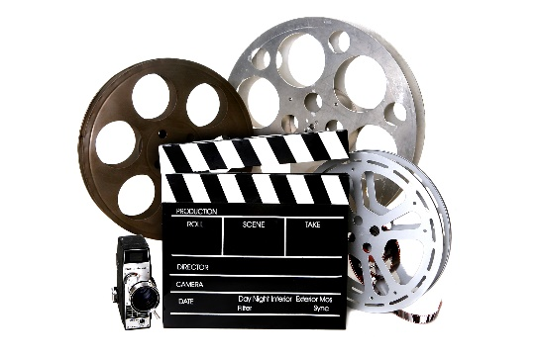
You will view the 2013 Baz Luhrmann version of The Great Gatsby. The film received a mix of reviews when it came out and now it’s time for your opinion to be shared after you have read the novel.

LEARNING GOAL:
Demonstrate knowledge of The Great Gatsby’s narrative elements, both in print and film and provide a detailed comparison of the two mediums.

WRITING A FILM REVIEW
Although there is not a set formula to follow when writing a film review, the genre does have certain common elements that most film reviews include:

- Introduction
- In the opening of your review, provide some basic information about the film. You may include film’s name, year, director, screenwriter, and major actors.
- Your introduction, which may be longer than one paragraph, should also begin to evaluate the film, and it should allude to the central concept of the review. A film review does not have to contain a thesis or main claim, but it should focus on a central analysis and assessment.

- Plot Summary
- Remember that many readers of film reviews have not yet seen the film. While you want to provide some plot summary, keep this brief and avoid specific details that would spoil the viewing for others.

- Description
- While the plot summary will give the reader a general sense of what the film is about, also include a more detailed description of your particular cinematic experience watching the film. This may include your personal impression of what the film looks, feels, and sounds like. In other words, what stands out in your mind when you think about this particular film?

- Analysis
- In order to explain your impression of the film, consider how well the film uses techniques and thematic content. How do the film’s formal techniques (such as cinematography, editing, lighting, sound, genre, or narrative) affect the way the film looks, feels, and sounds to you? How does the thematic content (such as history, race, gender, sexuality, class, or the environment) affect your experience and interpretation? Also, do the formal techniques work to forward the thematic content?
- How does the film compare to the text? What are significant similarities and differences? Does the film do the novel justice? Why might there be changes between the two? Do changes affect the story in any way?

- Conclusion/Evaluation
- The closing of your film review should remind the reader of your general thoughts and impressions of the film. You may also implicitly or explicitly state whether or not you recommend the film. Make sure to remind the reader of why the film is or is not worth seeing.

When writing your review, ensure that you provide specific examples, details, and evidence to support your responses.
SUCCESS CRITERIA:
[ ] Review is written with specific information about the film
[ ] Review contains detailed support, explanations, and related content
[ ] Review includes logical organization
[ ] Review provides information comparing/contrasting elements of the film and the novel
[ ] Review analyzes aspects of the film, including choices of the director/producer, impressions on the viewer, and the “feel” of the film
[ ] Review is edited for spelling, grammar, mechanics, and clarity
[ ] Length should be between 800-1000 words

RUBRIC:
CATEGORY | Below Expectations | Level 1:  Minimum Expectations | Level 2:  Some Expectations | Level 3:  Meeting Expectations | Level 4:  Exceeding Expectations
Review shows knowledge of the film’s information and details | This item has not been completed to minimum expectations | A limited amount of film details have been shown in the review | Some film details have been shown in the review | An effective amount of details from the film have been included | All or almost all details from the film have been included
Support and explanations are included within the review | This item has not been completed to minimum expectations | Support and explanations have been included in a limited manner | Support and explanations have been included in some manner | Support and explanations have been included in an effective manner | Support and explanations have been included in a superior manner
Information is organized in a logical manner | This item has not been completed to minimum expectations | Limited organization has been demonstrated | Some organization has been demonstrated | Great organization has been demonstrated | Excellent organization has been demonstrated
Details comparing/contrasting the film and novel are provided | This item has not been completed to minimum expectations | Limited connections between film and novel are provided | Some connections between film and novel are provided | Several connections between film and novel are provided | Many clear and awesome connections between film and novel are provided
The review includes an analysis of the film’s technical aspects | This item has not been completed to minimum expectations | Limited information about film’s technical aspects | Some information about film’s technical aspects | Considerable information about film’s technical aspects | Excellent information about film’s technical aspects
Review has been edited for spelling, grammar, mechanics, and clarity | This item has not been completed to minimum expectations | Limited editing has occurred | Some editing has occurred | Considerable editing has occurred | All/almost all editing has occurred

TOTAL: ________________

COMMENTS:

