The Great Gatsby focuses on a number of themes as they developed in the world of the Roaring ‘20s. You will be assigned a theme, (or you may choose your own) and you will create a digital collage using the art of John Held Jr.
Suggested Themes (One per Student)
SUCCESS CRITERIA
[ ] Assignment shows an understanding of novel’s themes through the analysis of 2-3 John Held Jr. drawings
[ ] Analysis includes a description of how each image connects to the appropriate theme
[ ] Connections between the theme and Chapters 1-4 of The Great Gatsby are made and supported
[ ] Information is displayed as a “digital collage” with images and descriptions arranged in an organized, clear manner
- Youth
- Freedom
- Women’s Liberation
- Rebellion
- Loss of Innocence
- Materialism/Frivolity
- Sexual Promiscuity
You may come up with your own theme

Assignment
- Once you’ve been assigned/chosen a theme, find 2-3 of John Held Jr.’s drawings that reflect the idea of this theme. Links to image collections are below. Copy the pictures to either PowerPoint or Word to create a digital collage. It is up to you if you want to create multiple slides/pages – but it can definitely be more than one! Ensure the images are of a size where details can be seen.
- For each image, provide a brief explanation of how you think the image reflects the theme. Arrange this information so it is visually aesthetic in keeping with the digital collage idea.
- Connect the theme with the first four chapters of The Great Gatsby. Document a minimum of two specific examples, (such as a quote or a paraphrase) of how the theme is integrated in the novel.
- Ensure your collage has a title page, including your name.
- Save your work to: Shares/Students to Staff/Wilson/ENG4U/YourName – Gatsby Theme
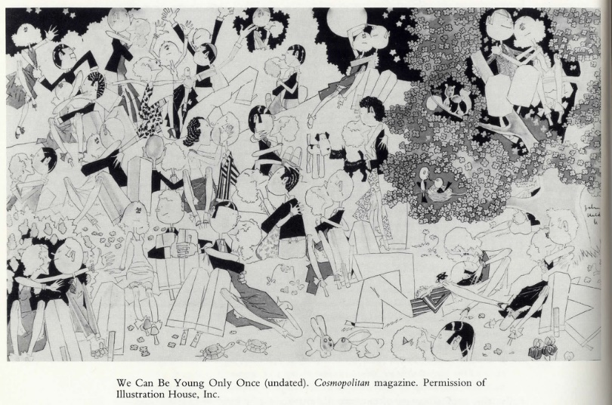

JOHN HELD JR. DRAWINGS – WEBSITES
http://ana-lee.livejournal.com/178989.html
https://wordsandeggs.wordpress.com/2009/09/16/throwback-thursday-1920s-illustrations-of-john-held-jr/
https://archive.org/details/worksjoh00held
You can find more if you Google Image “John Held Jr. Drawings”

