OVERVIEW/LEARNING GOAL:

You will prepare a short research assignment on an Ancient Civilization as background for Ishmael. This project will provide you (and the rest of the class) with information on the impact of the civilization on society and the world so you can build connections with the novel.
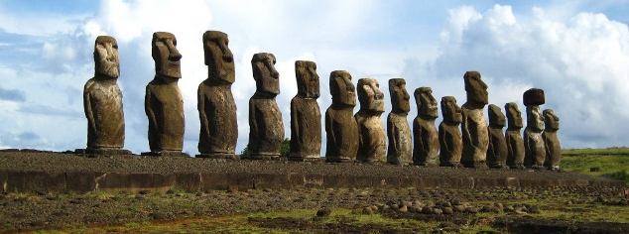

STEPS:
- Choose a Civilization from this list: https://en.wikipedia.org/wiki/Civilization#Early_civilizations
- You may choose any civilization you like, (as long as nobody else is using it), though I recommend the Medieval to Early Modern period. Do some research to ensure information is easily available before making a choice.

- Create a PowerPoint/Prezi/Google Slide with some information about your civilization. You should include things like:
- Where did they live? Did they migrate from somewhere? To somewhere?
- What is some background information, such as food/shelter/customs/art/etc.?
- What was this civilization’s impact on society? In your opinion, was the impact good or bad?
- Are there other pieces of information that are important about this civilization?
Your presentation should be between 6-8 slides (minimum) and include media elements such as pictures, videos, and maps. You must also include a Bibliography/Reference slide at the end with your sources. Finally, ensure your presentation has been properly edited. Consider the overall design of your presentation. What makes a presentation engaging?
- You will prepare your presentation and send it to me. I will upload the files to WilsonTeacher.ca for sharing.
SUCCESS CRITERIA:
[ ] My project contains detailed and specific information about an early civilization
[ ] The civilization focused on in my project is unique to other members of the class
[ ] The impact of this civilization on society has been outlined and detailed
[ ] Examples and explanations are sufficiently included for each element of the project
[ ] Media elements, (including maps, pictures, videos, etc.) are included to build engagement and share information
[ ] A Bibliography/Reference is included
[ ] The work has been edited for mechanics, spelling, and grammar

TOTAL MARKS /20

