OVERVIEW OF ASSIGNMENT:
Throughout this course, we have learned about the history and culture of First Nations, Métis, and Inuit people in Canada. Hopefully, you have gained an appreciation of the history, success, and challenges of Indigenous People.

For your Culminating Activity, you will create a report that includes a Person, Place, and Thing. Identity, research, and report on THREE important things about Canada’s aboriginal people. The catch is that you cannot use anything we have talked about as a class, (such as Residential Schools).

Examples might include:
- AFN Chief Perry Bellegarde; Louis Riel; Susan Aglukark (Persons)
- The Albany River System; Indian Friendship Centres (Places)
- Aboriginal business (like Wasaya Airways); Aboriginal inventions – like kayaks (Thing)

To make your choices, you can use your own knowledge, seek the help of the teacher, or use tools like Google to search for things like “Important Aboriginal Places in Canada” or something similar.

TASKS:
For each of your three topics, you will do the following:

- Complete an information/graphic organizer for each topic
- Write a report for each topic. Your report should be organized to include the following things as a suggestion:
a. Who/What It’s All About
b. Where it was located in Canada. This might change depending on topic
c. When was it around? What dates are important to this topic?
d. Why is this person, place, or thing important to Canada’s history?
e. Why did you choose this topic? What’s interesting to you about it? How does it connect to the class?
- Include graphics, pictures, maps, charts that provide more information about your topic.
- Include sources from where you got your information by creating a bibliography
- Ensure that spelling, grammar, and your ideas have been edited

You will have a minimum of five days of class time to complete this Culminating Assignment. It is important that you use your time in class appropriately as no extensions can be granted. If you’re stuck, ask the teacher for help!

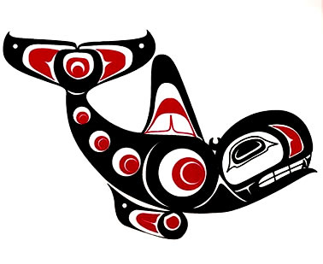
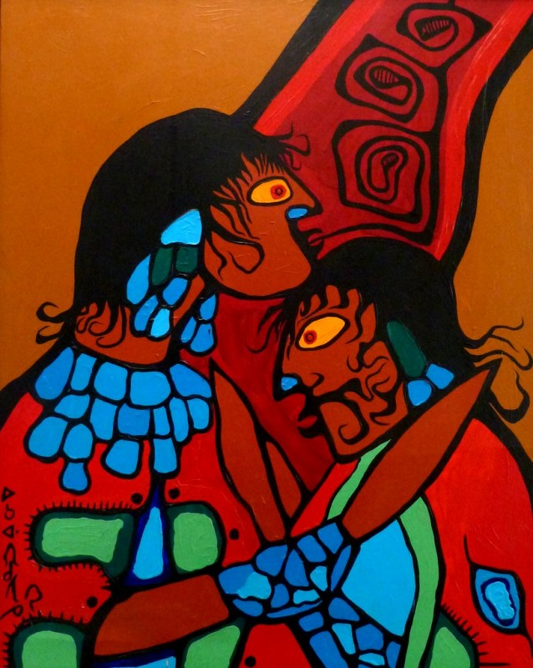
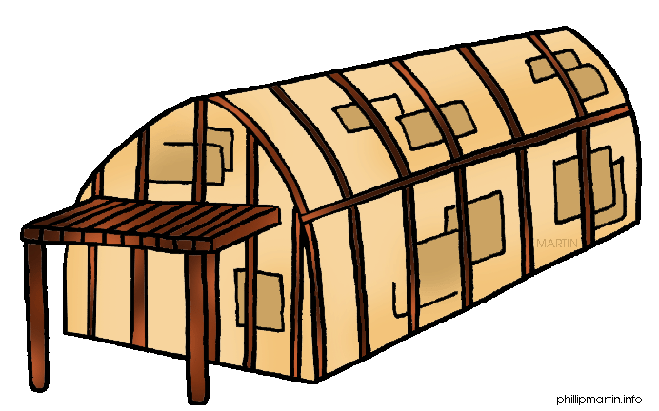
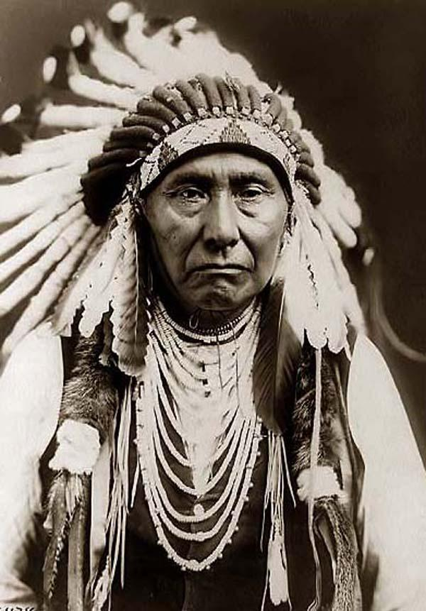

LEARNING GOAL:
To demonstrate an understanding of important First Nations, Métis, and Inuit topics and show how they connect to the main ideas of the course
SUCCESS CRITERIA:
-I will choose three topics that I have not explored in detail in the class so far
-I will create reports that include detailed information and support about the topic
-I will make sure to show why the topic is important for other people to know and explain how it connects to the
main ideas of this class
-I will make my report complete my including maps, pictures, graphics or charts, ensuring it is edited, and
including a bibliography

RUBRIC AND MARKING:
Each report will be marked using the same rubric. Each report will then be worth 33.3% of your “Final Mark,” which totals 30% of your NAC2O mark. Failure to complete some or all of this project can have a big effect on your overall grade in the course.

 | BELOW LEVEL 1 | LEVEL 1  (50-59) | LEVEL 2  (60-69) | LEVEL 3  (70-79) | LEVEL 4  (80-100)
Report includes specific details about what topic is about and is explained with examples | The report does not include details about the topic | The report includes limited details about the topic | The report includes some details about the topic | The report includes quite a bit of information about the topic | The report goes above and beyond in its information about the topic
Report includes specific details about why the topic is important to history and is explained with examples | The report does not include this information | The report includes limited details about why the topic is important | The report includes some details about why the topic is important | The report includes considerable details about why the topic is important | The report contains a great amount of details about why the topic is important
Report includes the student’s reason for choosing the topic and how it connects to the class | The report does not include this information | The report has limited reasons by the student for how the topic connects with the class | The report has some reasons by the student for how the topic connects with the class | The report as several reasons for how the topic connects with the class | The report clearly explains how the student sees the topic connecting to the class
Graphics, pictures, maps, and diagrams are included to add information to the report. These graphics clearly connect to the topic. | The report does not include this information | The report makes limited effective use of graphics, pictures, maps, or diagrams | The report makes some effective use of graphics, maps, pictures, or diagrams | The report makes considerably effective use of graphics, maps, pictures or diagrams | The report makes a very effective use of graphics, maps, pictures, or diagrams
The report has been edited for spelling and grammar | The report has not been edited | Limited editing has been completed for this report | Some editing has been completed for this report | Almost all of the report has been edited effectively | The report has been effectively edited
A bibliography has been included with the report | The report does not include this information | Limited information is included in the bibliography | Some information has been included in the bibliography | Almost all of the information has been included in the bibliography | All of the information has been included in the bibliography

OVERALL LEVEL: _________ = ______%

PERSON, PLACE, OR THING ORGANIZER

Use the chart to record information and research about the person, place, or thing you are learning about. You may create your own chart if you need more space.

PERSON, PLACE, OR THING’S NAME/TITLE:
WHAT IT IS – DETAILS ABOUT THE TOPIC:
(WHERE IT IS LOCATED, IMPORTANT DATES, WHO WAS INVOLVED)

WHY IT’S AN IMPORTANT PART OF FIRST NATIONS, MÉTIS, AND INUIT CULTURE

WHY DID YOU CHOOSE THIS TOPIC? WHAT DID YOU FIND INTERESTING ABOUT IT?

HOW DOES THIS TOPIC CONNECT TO THE MAIN IDEAS OF THE COURSE?

WHERE DID YOU FIND YOUR INFORMATION?

OTHER DETAILS/INFORMATION TO INCLUDE:

