ENG 3U SHORT STORY UNIT: CULMINATING ASSIGNMENT
Wilson

For this assignment, you will read a short story that you select from the website http://www.onlineclasses.org/2011/01/20/the-50-best-short-stories-of-all-time/

After reading the story, you will complete the following steps:
- Complete a SHORT STORY ANALYSIS SHEET for your selected story

- Design a cover for your story (may be designed with graphic/photo-editing software or by hand)

- Create a visual project for the story. It can be based on the story itself or it can be based on theme, character(s), conflict(s), setting, or a combination of these elements. Suggestions for your visual element include:
- Collage (i.e. full Bristol Board)
- Dramatized Version of Story (i.e. a short play)
- Video or Animation (i.e. television commercial/TV episode)
- Comic or Graphic Novel (Retelling the story visually)
- Painting/Sculpture based on story

- Artistic Statement that clearly explains (in a paragraph or two) your visual choice and what it represents both in terms of the story you chose and in your own interpretation
You will be given time in class to investigate various short stories. It is recommended that you use other sources (i.e. Sparknotes – Short Stories – to help you in your decision-making and understanding of your selection. Other time in class may be provided to put pieces of this assignment together, though you will be expected to do some work at home.
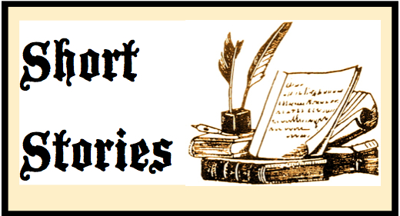
It is expected that you include high effort, planning, thoughtfulness and creativity in your visual representation. The above ideas are suggestions. If you have other ideas for visually representing your story, see the teacher for approval, first!

LEARNING GOALS & SUCCESS CRITERIA/MARKING:
Learning Goal:
I will demonstrate an understanding of short fiction elements by analysing the story and representing its main ideas in a visual manner.

Success Criteria:
[ ] Story selected from The Fifty Best Short Stories of All-Time website
[ ] Short Story Analysis questions completed thoroughly, and with sufficient support in responses
[ ] Detailed plot graph has been included, showing all necessary components
[ ] Visual Element selected and planned appropriately
[ ] Visual Element clearly explained through Artistic Statement
[ ] Visual Element shows understanding of story elements
[ ] Visual Element shows thoughtful interpretation of short story ideas
[ ] Visual Element demonstrates creativity and high degree of effort
[ ] Short Story Cover is creative, thoughtful and appropriate

Rubric:
CATEGORY | LEVEL 1  Below Expectations | LEVEL 2  Meets some expectations | LEVEL 3  Meets Expectations | LEVEL 4  Exceeds Expectations | MARK COMPARISON  DUE DATES:
K/U:  Student demonstrates knowledge of short stories | Student demonstrates limited knowledge of genre | Student demonstrates some knowledge of genre | Student demonstrates considerable knowledge of genre | Students demonstrates thorough knowledge of genre | /15  FINAL COPY DUE:
T/I:  Student connects ideas and supports understanding | Student demonstrates limited ability to connect ideas | Student demonstrates some ability to connect ideas | Student demonstrates considerable ability to connect ideas | Student demonstrates thorough ability to connect ideas | /10
COM:  Information is communicated clearly and effectively | Student has limited ability to communicate information and ideas | Student has some ability to communicate information and ideas | Student has considerable ability to communicate information and ideas | Student has thorough ability to communicate information and ideas | /10
APP:  Information is presented and displayed creatively and effectively | Student has limited ability to apply knowledge and information | Student has some ability to apply knowledge and information | Student has considerable ability to apply knowledge and information | Student has thorough ability to apply knowledge and information | /15
TOTAL: /50

ENG 3U Short Story Analysis
Wilson
Choose a short story of appropriate length. Using that story, answer the following questions. Be sure to use specific details, examples, and quotations from the text to support your ideas.

1. Make a plot diagram including all components (introduction with inciting event, rising action, climax, falling action, and resolution). List the major events of the story on the diagram. You may use numbers and a legend, if you wish. (COMPLETE THIS ON A SEPARATE PAGE)
2. What is the central theme of the story?
3. What is the main conflict type and who/what is it between?
4. Choose one character and write a character sketch in a well-developed formal academic style paragraph. Be sure to include several aspects of character analysis. Use examples and quotations to support your claims.
5. Who are the protagonist and antagonist? Is there a foil character? If so, explain the use and effectiveness of the contrast.
6. What is the mode of narration? How do you know this? (Give quotations). Why do you think the author chose this style of narration for this piece?
7. What is the setting?
8. Describe the atmosphere using examples and quotations from the text.
9. Give an example and explain how FOUR of the following literary devices are used in the story:
- Metaphor
- Onomatopoeia
- Oxymoron
- Pathetic Fallacy
- Personification
- Repetition
- Satire
- Simile
- Symbolism

- Allegory
- Allusion
- Euphemism
- Foreshadowing
- Hyperbole
- Imagery
- Irony
- Juxtaposition

